PLL Group Rules

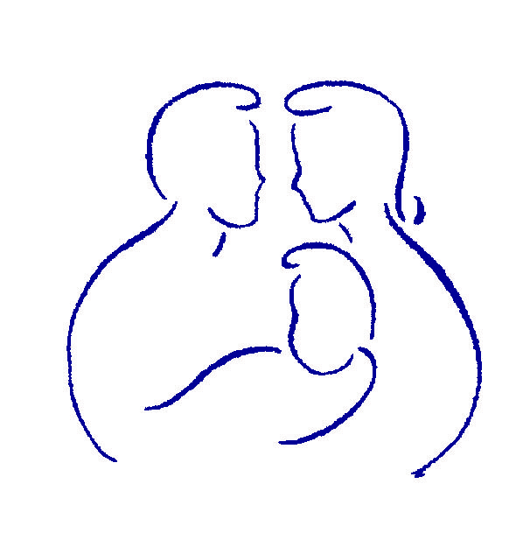
© 2005-2011 Savannah Family Institute, Inc. All rights reserved. Patent Pending (US 61/429,536)

www.gopll.com

Parenting with Love and Limits®
www.gopll.com
With the exceptions noted below, no part of these handouts may be reproduced
or transmitted in any form without written permission from Savannah Family Institute, Inc.

LIMITED PHOTOCOPY LICENSE
Savannah Family Institute grants to PLL’s certified mental health professionals non-assignable permission to reproduce pages of these handouts for personal use in clinical practice and not for resale or redistribution. These materials are intended for use only by qualified mental health professionals. This license is limited to the individual participant and does not extend to others. The license does not grant the right to reproduce these materials for other purposes (including but not limited to books, pamphlets, articles, video or audio tapes, handouts or slides for lectures or workshops.) Permission to reproduce these materials for these and any other purposes must be obtained in writing from Savannah Family Institute, Inc.

PARENTING WITH LOVE AND LIMITS (PLL)
GROUP RULES

- Arrive on time: Group begins promptly at 5:00 pm.
- Turn off phones at start of group at 5:00 pm, with no incoming/outgoing calls or texts until group is over at 7:00 pm.
- Use bathroom either before the start of group or during the break.
- Talk in a respectful manner, with no profanity, crude language, or inappropriate topics.
- While at PLL facility, refrain from any gang/group apparel, signs, or references.
Please note that if any of these rules are violated:
- You will receive up to two clear verbal warnings per class from PLL facilitator.
Failure to comply with warnings will result in your parent/caregiver being called in to remove you from class for the remainder of the evening. The next day, your probation officer will be notified of this event. In cases of extreme or continued disrespect or disruption, PLL reserves the right to ask youth to not return to group for the remainder of the cycle.

My signature below certifies that I have read and agreed to the rules detailed above.
______________________________ ______________________
Parent/Guardian’s Signature Date
______________________________ ______________________
Youth’s Signature Date
______________________________ ______________________
Witness Signature Date

