Parenting with Love and Limits®
Helping Organizations Restore Families™

Presentation Planner



Main Office
2401 E. Peach Tree Dr.
Chandler, AZ 85249
Phone (800) 735-9525
FAX (866) 512-2067

 | Parenting with Love and Limits®  www.gopll.com | 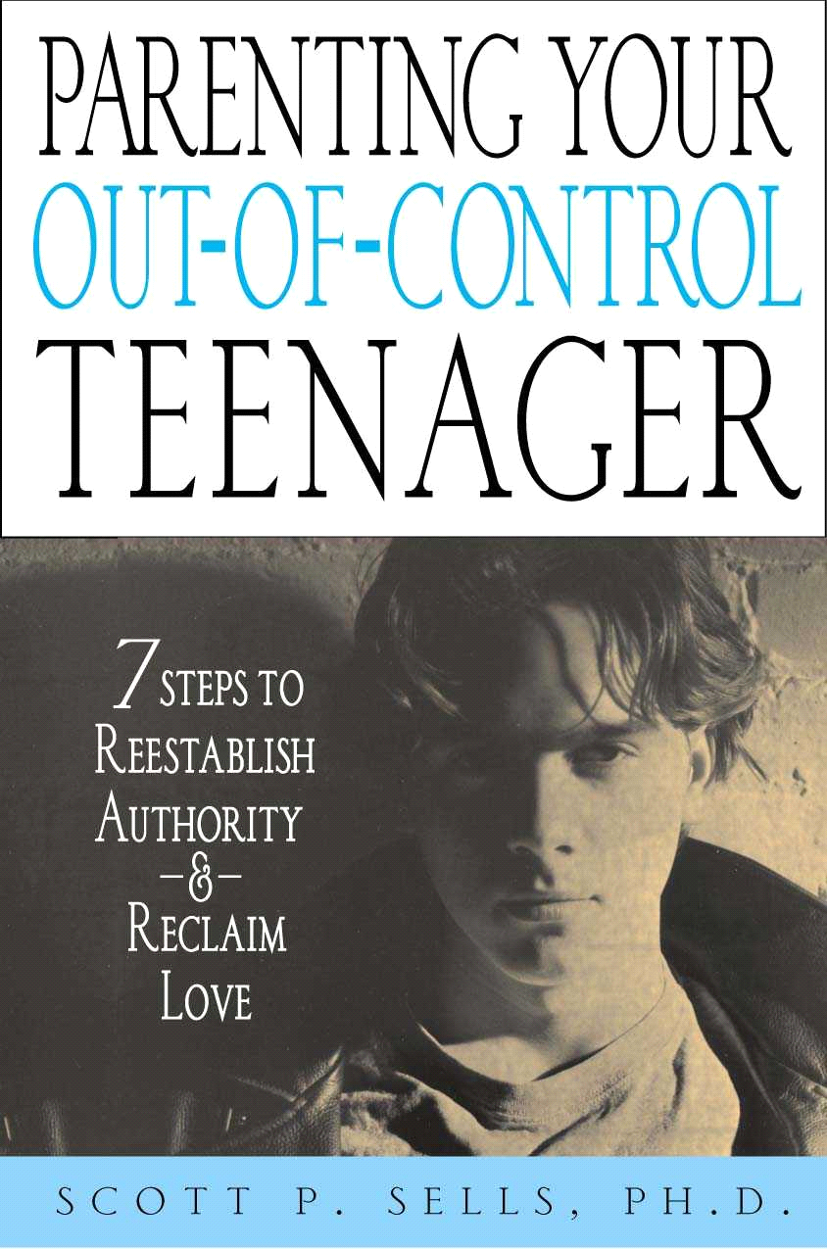  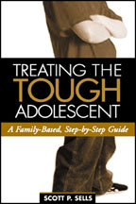

Thank you for your interest in Parenting with Love and Limits’ presentations dealing with the treatment of tough and defiant adolescents and their families. We look forward to conducting a workshop for your organization in the near future!

Enclosed you will find information on planning a workshop, including…

- A workshop checklist
- Complete descriptions, course objectives and agendas for each workshop
- About the author
- References

If you would like to receive a short video describing our workshops and what makes them unique, please call or e-mail us. We will be more than happy to send you a copy!

Once again, we look forward to working with you. If you have any additional questions, or would like to schedule a presentation, please contact us at the e-mail address or phone number below.

Sincerely,

Scott P. Sells, Ph.D.
CEO
Savannah Family Institute, Inc.

Workshop Checklist

- Decide on a Topic for Your Workshop

PLL currently conducts workshops on several different applications for treating tough adolescents, tough children, and their families. PLL currently offers the following standard workshops, any of which can be tailored to meet the needs of almost any agency, group or type of population you work with, such as residential treatment, foster care, or community or school-based problems:

- Treating Your Out of Control Teenager: A 7-Step Model to Restore Love and Limits
- Engaging Resistant Parents
- Undercurrent Therapy: Treating the Secret Wounds of Kids and Adults
- The Direct Link between Unresolved Trauma & Children with Extreme Behavioral Problems

- Call and Schedule a Date for Your Workshop

The first order of business is to call and schedule a date for the workshop. The calendar fills very quickly, so please call early. One suggestion -- from our experience, therapists working in agencies typically prefer workshops conducted during the work week. On the other hand, professionals in private practice tend to prefer that at least one day of the workshop occur on a weekend so they do not have to miss two days of work.

Parenting with Love and Limits® is proud to provide its founder and CEO, Dr. Scott P. Sells (see the attached biographies) to present at your workshop.

To schedule your workshop, please contact:

John Burek
Savannah Family Institute, Inc.
Toll Free 1-800-735-9525
Direct Line (863) 255-4654
Fax (866) 852-5113
Email: jburek@gopll.com

- We Will send You a Training Agreement

Once we have settled on a date and scheduled Dr. Sells, we will mail you a simple Speaker Agreement outlining the details of our agreement. This agreement will include the following information: (1) dates for the presentation; (2) statement of presentation fee and other costs; (3) presentation topic; (4) statement of cancellation policy.

Please note that presentation dates are not guaranteed until the Speaker Agreement has been received and signed by both parties. You may fax the agreement to PLL at: (866) 512-2067.

- Produce and Mail Your Own Brochure

Upon your request, we will be happy to supply you with sample brochures. Please feel free to copy from these samples to create your own brochure. If you have any questions or would like our input, please call us at 1-800-735-9525.

Workshop Descriptions

Treating Your Out of Control Teenager: A 7-Step Model to Restore Love and Limits

Our most popular workshop is based on Dr. Sells’ first book, Treating the Tough Adolescent: A Family-Based Step by Step Guide (Guilford Press, 1998) and his recent best-selling book, Parenting Your Out-of-Control Teenager: 7 Steps to Reestablish Authority and Reclaim Love (St. Martin’s Press, 2001).

This presentation will demonstrate a 7-step approach to engaging the uncooperative parent and adolescent or child, end button pushing, re-establish authority through ironclad contracts, and restore lost nurturance between parent and child. Using video, case examples, and role-plays, you’ll learn how to apply all 7-Steps.

After helping parents understand why their child is out of control, the model deals with such issues as how to reduce parents’ knee-jerk reactions, how to contract for change, how to set up creative consequences, how to reintroduce nurturance once behavior comes under control, and how to look for the underlying problems, such as marital discord or substance abuse, that often block success.

You will also learn the specific consequences necessary to stop the child’s seven aces of: truancy, running away, suicidal threats, violence, disrespect, sexual promiscuity, and drug and alcohol abuse.

You’ll leave with a full tool kit for helping parents improve their parenting skills and knowing how to reach the resistant child or adolescent.

Presentation material may be tailored to both general public and clinical audiences.

"Dr Sells' book offers a sensible and strategic approach to resolving the family problems of difficult kids…This is a valuable book that wedges research-supported ideas into practical guidance for therapists struggling with exasperating children and their families."
-Jay Haley, Founder of Strategic Family Therapy

Course Objectives

- Diagnose why children and adolescents are oppositional and how to effectively treat this population through the illustration of specific clinical markers diagrammed within the 7-Step SFI Model.

- Learn and apply specific principles and guidelines on how to engage the uncooperative child or adolescent, plus creative consequences to stop the extreme behaviors of substance abuse, violence, suicide, disrespect, truancy, and running away.

- Learn and apply specific principles and guidelines on how to engage the uncooperative parents, empower the single parent, and change parent-child communication and confrontational patterns, plus six strategies to restore tenderness within the family.

- Introduction to the application of the strategies identified in Dr. Sells’ book Parenting Your Out-of-Control Teenager, and to show parents why their children or teens misbehave, and the 7-step process needed to reestablish their lost authority and restore lost nurturance.

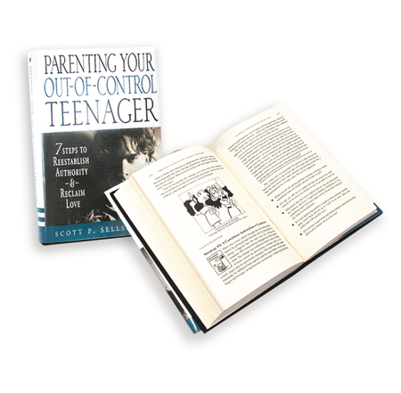
- Learn the real reasons for teen misbehavior
- Make and ironclad contract to stop that behavior
- Troubleshoot future problems
- End button-pushing
- Stop the “seven aces”
- Mobilize outside help
- Reclaim lost love within the family

Engaging Resistant Parents

According to the latest research, active parental participation is the missing link to preventing high risk juveniles from entering commitment or relapsing once they transition back into the community from institutional treatment. This presentation will illustrate three unique ways to engage the parents and the family to prevent relapse: (1) A unique combination of group and family therapy to teach parents missing core skills; (2) Motivational interviewing tactics and the clear boundaries to quickly engage families; (3) Recognizing the links between unresolved trauma, delinquent behavior, and actively treating unhealed wounds.
Learning Objectives:
Participants who complete this workshop will:
- Learn how focusing on the individual juvenile without an equal focus on the family will lead to high relapse rates and what the future implications of this continued practice holds.
- Learn how the Parenting with Love and Limits (PLL) model is using a combination of group and family therapy in a brief treatment format that is uniquely different from other models to engage the most resistant parents to achieve 75% graduation rates without a court order. Video tapes and research outcomes will illustrate how this is possible.
- Learn how PLL uses motivational interviewing tactics, clear boundary setting, and wound work to get the parents quickly engaged and how satellite sites are used to treat families in hard to reach rural communities.
- Learn how PLL is creatively being used in other communities to keep high risk juveniles on probation out of residential treatment, and how PLL is keeping those youth returning back into the community from residential in home, in school, and out of trouble with the law.

Undercurrent Therapy: Treating the Secret Wounds of Kids and Adults

When therapy bogs down, the most likely reason is that we’ve missed “undercurrents” — secret wounds such as unmourned losses, abandonment, violence, and other family secrets — all the things no one wants to talk about. In this workshop, you’ll learn how to decipher the secret language of undercurrents, and how to ask the questions that will bring them to the surface.

Using videotaped case examples and role plays, Dr. Sells will demonstrate techniques to help disarm parent, child, and adult defenses, generate therapeutic intensity, and choreograph enactments that bring avoided issues into the open. You will learn the optimal timing for undercurrent therapy and examine ethical and spirituality considerations that may arise. We discuss the use of this work with difficult kid problems, such as ODD, attachment disorders, conduct disorders, depression, substance abuse, eating disorders, and ADHD, and adult problems such as marital dysfunction, anxiety, and personality disorders.

This seminar material is appropriate for a clinical audience.

Course Objectives

- Learn how to unstick your impossible cases by identifying the “undercurrents” or underlying themes, such as wounds, abandonment, fear, violence, family secrets, role confusion, or suicidal thoughts, which lead to the re-birth and maintenance of horrific problems (conduct disorders, ADHD, eating disorders, substance abuse or depression).

- Learn how to take solution-focused treatment to the next level by using the technique of scaling to uncover your clients’ deep wounds that are keeping them stuck and unable to move forward.

- Learn to spot undercurrents through your clients’ body language and the specific questions needed to bring them out into the open.

- Through video examples, learn to apply the specific techniques of “fever-making,” “process choreography,” “therapeutic rule breaking,” and the “function of the symptom” to promote healing of these undercurrents in your clients and families.

- Learn to combine spiritual concepts with techniques of undercurrent therapy to aid in the treatment of difficult populations of conduct disorders, depression, substance abuse, eating disorders, and attachment disorders.

- Learn to evaluate ethical considerations, as well as the optimal timing of when and how to use these therapeutic techniques to uncover deep wounds.

The Direct Link between Unresolved Trauma and Juvenile Delinquency

Research has recognized there are direct links between children with unresolved trauma issues and delinquent unruly behavior. Unfortunately, the majority of treatment for juvenile delinquency focuses on behavioral issues and misses the root causes of the problem: unhealed wounds or traumas such as abandonment, unresolved grief, or abuse and neglect. Parenting with Love and Limits has developed unique components to accurately identify those youth in detention who have had significant trauma or loss, and then implement step-by-step methods to heal the unresolved trauma issues both within the juvenile and their family. A complete overview of the Parenting with Love and Limits models will be presented, including assessment procedures, treatment methods, and aftercare alternatives.
Learning Objectives:
Participants who complete this workshop will:
- Learn the reasons why direct links between children with unresolved trauma issues and delinquent unruly behavior have been overlooked and left largely untreated.
- Learn how PTSD (post-traumatic stress disorder) is used to carefully assess, screen, and quickly identify juveniles in detention who have significant and unresolved trauma issues. Research results will be provided.
- Outline a six session family coaching model and five session parenting group through the Parenting with Love and Limits program that answers the question “now what?” Once the unhealed trauma has been identified, how the problem is permanently healed in the here and now. The step-by-step process of how this healing takes place with the juvenile and the entire family is illustrated using video demonstrations and role plays. Research outcomes are highlighted.
- Learn how the Parenting with Love and Limits Program forms a system of care that begins with the assessment and identification of the trauma and ends with concrete treatment methods to heal the trauma on a permanent basis with the entire family.

Tailoring the Workshop Topics

The following are examples of topics that can be implemented into your program agenda to fit your specific needs.

Foster Care

Learn how to collaborate with multiple agencies that often possess different treatment philosophies in opposition to one another. Learn how to stop the cycle of foster children being moved from one placement to another. Get a roadmap to effectively engage larger systems.

School-Based Problems

School bullying, disruptive classroom behavior and lack of parental involvement are common problems in today’s schools. Learn specific techniques both within and outside the classroom to directly address these issues. An anger control program will be highlighted.

Juvenile Sex Offenders

Understand the cycle of abuse, including the type of family environment that is prone to creating a sexually abusive situation, and how and why the abuse occurs. Master the identification of the concrete and subtle signs that lead to the cycle of abuse. Learn how to effectively use family systems theory in working with Juvenile Sex Offenders as well as understand family dynamics in the treatment of Juvenile Sex Offenders

About the Author

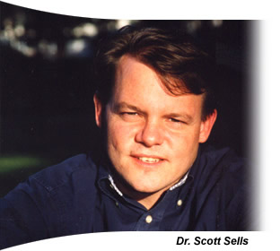 | Due to the wide acceptance of his books, Dr. Scott P. Sells has gained national recognition as an expert in the treatment of difficult teenagers. Through Dr. Sells’ Parenting with Love and Limits® system of care model and various presentations, he has reached thousands of program administrators, professionals, and parents. Dr. Sells has been a practicing therapist for over 20 years, and has helped treat over 5,000 out-of-control teenagers and their families.  Background. Dr. Sells holds doctorate degrees in both Social Work and Family Therapy from Florida State University and a Master’s degree in Social Work. He has previously served as a Full Professor at Savannah State University, teaching masters students in advanced clinical practice. Dr. Sells serves as a consultant for the Department of Juvenile Justice, and is the
CEO of the Savannah Family Institute. Dr. Sells has received widespread media coverage for his work with an inner-city neighborhood, establishing a community center clinic that will treat at-risk children using the principles from his books. Dr. Sells works with Juvenile Justice, Residential Treatment, and Foster Care Agencies across the United States and Europe implementing his evidence-based Model Program, Parenting with Love and Limits®. To date, the Parenting with Love and Limits Model has been successfully implemented in 16 states and The Netherlands.

Professional Memberships and Certifications

American Association for Marriage and Family Therapy - Approved Supervisor
Licensed Clinical Social Worker (Lic # 01790-C)
Licensed Marriage and Family Therapist (Lic # 01456)

Publications. Dr. Sells’ first book, entitled Treating the Tough Adolescent: A Family-Based, Step-by-Step Guide (Guilford, 1998), was based upon a four year outcome study of 82 difficult teenagers and their families. This book was featured as the alternate main selection in the Behavioral Science Book Club.

Dr. Sells’ wrote his second book, entitled Parenting Your Out-of-Control Teenager: 7 Steps to Reestablish Authority and Reclaim Love (St. Martin’s, 2001), because current parenting books and counseling programs often did not address the special circumstances specific to the out-of-control teenager. This book is based upon a four year research study and contains the seven critical steps parents need to restore both love and limits with their teenagers.

In addition to these two books, Dr. Sells has had over a dozen major publications in preferred journals, plus a book chapter in the Handbook of Family Therapy Research Methods (Guilford, 1996).

Conference Presentations. Dr. Sells has extensive experience as a keynote speaker for national professional organizations like the American Association of Marriage and Family Therapy, the National Association of Social Workers and the Southeastern Psychological Association. He has also presented at national and international conferences for the International Family Therapy Association, the Character Education Partnership, the American Correctional Association, the Council on Social Work Education and at state conferences for the Nevada Association for Marriage and Family Therapy, the Georgia Association for Marriage and Family Therapy, the Massachusetts Association for Marriage and Family Therapy, the Arizona Association of Marriage and Family Therapy, Clinical Social Workers’ Association and the School Social Workers’ Association of Georgia. Dr. Sells was invited to be one of six expert presenters at the American Association of Marriage and Family Therapy’s prestigious Summer Institutes in Park City, Utah, and the Cape Cod Institute in Cape Cod, Massachusetts, honors given only to those in the field who are demonstrating cutting edge work in the field. In addition to Dr. Sells’ ongoing clinical supervision, he has recently given presentations for the Wyoming Supreme Court, Heartland for Children, and the Missouri Juvenile Justice Association, as well as conducting therapist trainings for the State of Alaska, Berrien County, Michigan, Family Court Division, 16th Judicial Circuit of Missouri, and the Middle Peninsula/Northern Neck Community Services Board, Virginia.
References

Please feel free to contact any of the individuals listed below who have served as past sponsors of workshops by Parenting with Love and Limits®.

Vivian Murphy
Executive Director
Missouri Juvenile Justice Association
P.O. Box 1332, Jefferson City, MO
Phone: 573-636-6101
E-mail: Vivian@mjja.org

Sander van Arum

Center for Ambulatory Forensic Psychiatry De Waag

Postbus 1362

3500 BJ Utrecht

The Netherlands

Phone: 0031 30 272 0685

Email: Svanarum@dewaag-nederland.nl

Glenda Bainbridge

Program Manager

Family Court Division, 16th Judicial Circuit of Missouri
625. E. 26th St.
Kansas City, MO 64108

Phone: (816) 881-8301

Email: Glenda.bainbridge@courts.mo.gov

