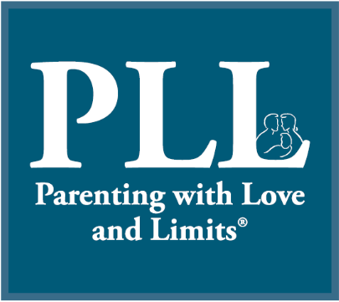

TEEN unpredictables

© 2005-2016 Savannah Family Institute, Inc. All rights reserved.

www.gopll.com
www.gopll.com
With the exceptions noted below, no part of these handouts may be reproduced
or transmitted in any form without written permission from Savannah Family Institute, Inc.

LIMITED PHOTOCOPY LICENSE
Savannah Family Institute grants to PLL’s certified mental health professionals non-assignable permission to reproduce pages of these handouts for personal use in clinical practice and not for resale or redistribution. These materials are intended for use only by qualified mental health professionals. This license is limited to the individual participant and does not extend to others. The license does not grant the right to reproduce these materials for other purposes (including but not limited to books, pamphlets, articles, video or audio tapes, handouts or slides for lectures or workshops.) Permission to reproduce these materials for these and any other purposes must be obtained in writing from Savannah Family Institute, Inc.

Teen Unpredictable
This week, do all your chores and one extra one that you don’t normally do. This will totally shock your parents.

Teen Unpredictable
One night this week, ask your mom or dad out of the blue if you can prepare or cook dinner for everyone.

Teen Unpredictable
The next time your parent lectures or preaches to you, suddenly say, “Mom or dad, you are right. I am going to go do some homework now.”

Teen Unpredictable
Hug your parent and say, “I love you.”

Teen Unpredictable
Leave little cards all over the house telling your parent all the things you appreciate about them.

Teen Unpredictable
Do homework or a chore without being asked.

Teen Unpredictable
Clean your room, and then invite your parent in for a tour of your “new and improved” living space.

Teen Unpredictable
Make a collage for your parent about how much they mean to you (with pictures of your parent, pictures from a magazine, drawings, etc.) They probably haven’t gotten this kind of art work from you since you were little.

Teen Unpredictable
The next time your parent is watching his or her favorite show, pop them a bowl of popcorn (or fix them some other snack) and go sit down and watch the show with them.

Teen Unpredictable
Bubbles of Love. The next time your parent looks down or sad, surround him or her with bubbles and say how much you love him/her.

