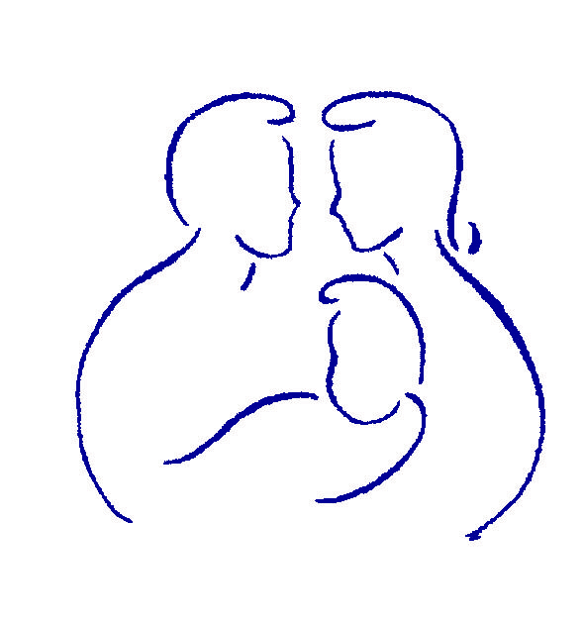

www.gopll.com

Parenting with Love and Limits®

Three Permutations of the PLL System of Care

Type of Model | Population Served | Delivery System | Personnel
PLL Front End-Diversion  Low to Moderate Risk | - Highest Priority- 1st and 2nd Time Offenders- Misdemeanor and Status Offenses- Not on probation  - Second Priority- Parents call no charges but want to file an unruly or ungovernable | - Outpatient Therapy  - Level 2- PLL Group Therapy-6 weeks  - 3 to 6 Coaching Sessions on average  - 6 to 8 weeks avg. stay | 1 Master’s /  1 Bachelor’s
PLL Extended Care  Moderate to High Risk | - Highest Priority- Chronic offenders on probation  - Second Priority- Extremely high risk for residential or out-of-home placement | - Home-Based Therapy  or Outpatient Therapy  - Level 2- PLL Group Therapy-6 weeks  - 20 Coaching Sessions on average  - Level 1-PLL Psycho-educational-optional  - 5 to 6 months avg. stay | Master’s Level Only
PLL Probation  Low Risk Only | - Oppositional Defiant Youth Only. With Behavioral Problems no mental problems or serious conduct disorders.  - Parents call no charges but want to file an unruly or ungovernable  - 1st Time Offenders- Misdemeanor and Status Offenses- Not on probation | - Probation Office  - Level 1- PLL Psycho-educational only  - 3 Coaching Sessions  - 6 to 8 weeks avg. stay | Bachelor’s Level  Probation Officer

