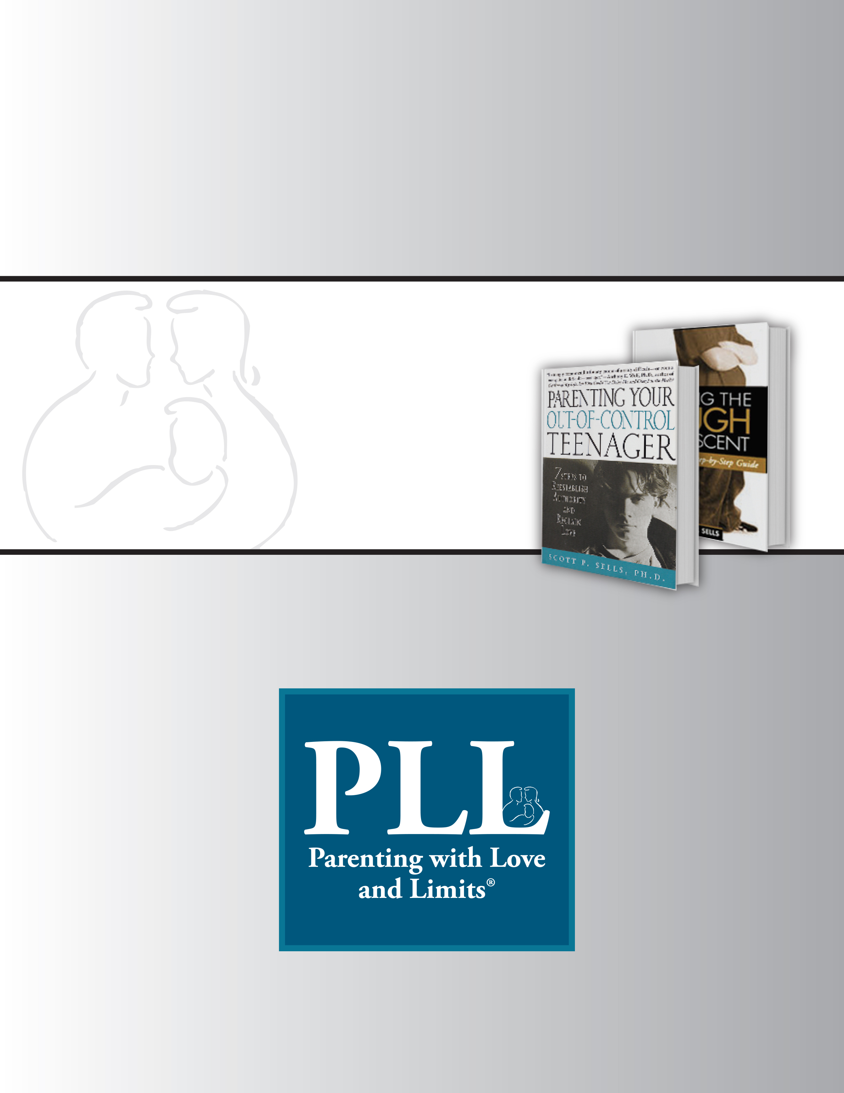

Research Track Checklist
PREPARED BY: PLL

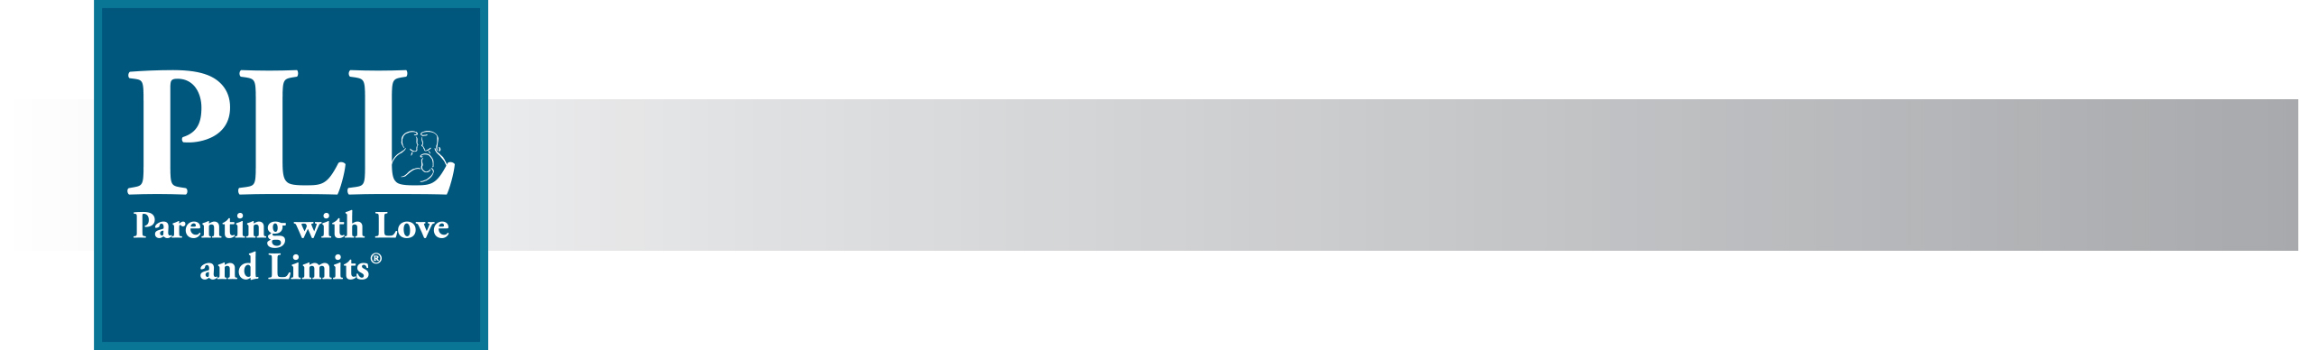
Research Track Checklist

Contract Holder ____________________________________________ Date _________________

Annual Trend Analysis |  |  | Quasi-Experimental Study
Minimum Requirements |  |  | Minimum Requirements
 | All data entered into PLL Database (i.e. demographics, cohorts, referrals, etc.) |  |  | All data entered into PLL Database (i.e. demographics, cohorts, referrals, etc.)
 | Operating only 1 PLL Team (30 families or less per year) |  |  | Operating two or more teams (60 or more families per year)
 | 80% or Higher Internal Measures received by PLL that meet below requirements: |  |  | Be in operation for a minimum of 3 years (if contract ends prior to 3 years, QE study will not occur)
- Clearly identified Pre-test/Post-test  - Unique youth identifier that matches PLL database  - Clearly identified family member completing instrument  - Same person completes pre- and post-test  - All questions answered on Internal Measures  - All Internal Measures received by PLL within two weeks of end of annual license period  - Administer Pre-test before any PLL treatment begins  - Administer Post-test at the last PLL session, upon completion of the PLL program |  |  |  | Minimum of 100 youth post 12-month discharge from PLL program within same population (i.e. Reentry vs. ATP)
 |  |  |  | Matched Group Availability
 |  |  |  | 80% or Higher Internal Measures received by PLL that meet below requirements:
- Clearly identified Pre-test/Post-test

- Unique youth identifier that matches PLL database & matches state or county database

- Clearly identified family member completing instrument

- Same person completes pre- and post-test

- All questions answered on Internal Measures

- All Internal Measures received by PLL within two weeks of end of annual license period

- Administer Pre-test before any PLL treatment begins

- Administer Post-test at the last PLL session, upon completion of the PLL program

Research Track:

Annual Trend Analysis

Quasi-Experimental Study

__________________________________________________________ ________________________
Customer Signature Date

Appendix A: Sample of Outcomes for Annual Trend Analysis Track

Appendix B: Sample of Outcomes for Quasi-experimental Track (QE Report)

Appendix A: Sample of Outcomes for Annual Trend Analysis Track

CHAMPAIGN COUNTY (ILLINOIS) EXTENDED CARE

Youth Emotional and Behavioral Outcomes
Child Behavior Checklist (CBCL) Assessment
Child Behavior Checklist (CBCL) Scales

Parenting with Love and Limits® (PLL) is an evidence-based treatment program designed for adolescents, ages 10-18, with severe emotional and behavioral problems, alcohol or drug use, truancy issues, domestic violence, suicidal ideation, depression or ADHD. The program integrates family and group therapy and addresses unhealed wounds, such as post-traumatic stress disorder, in a comprehensive system of care for adolescents and their families. The program is comprised of six group sessions plus six or more family sessions. In group therapy parents and teens learn specific skills and then meet in individual family coaching sessions to role-play and practice these new skills. This integration of group and family therapy enables parents to transfer these new skills to real-life situations with the primary focus of relapse prevention. The inclusion of wound work, when applicable, provides youth and families with an opportunity to engage in further coaching sessions designed to address remaining issues and prevent relapse. PLL is the only family centered program that combines both group and family therapy, a critical combination that increases the readiness of both youth and families to engage actively in the program. PLL has been utilized effectively with a variety of youth, such as those receiving mental health services, as diversions for first time offenders, youth on probation, alternatives to detention, alternatives to commitment, as well as youth reentering society from a residential placement.

A primary goal of the Parenting with Love and Limits model is to reduce emotional and behavioral problems among the youth served. To assess this goal over the course of PLL programming, the Child Behavioral Checklist (CBCL) was administered to youths’ parents/guardians prior to the start of services and again at the conclusion of PLL treatment. The CBCL provides measures on scales including:

- Rule Breaking
- Aggressive Behaviors
- Internalizing Behavior
- Externalizing Behavior
- Oppositional Defiant Behavior
- Conduct Disorder
- Total Problems

A total of 33 youth released from extended care PLL services during fiscal year 2011-2012 completed pre- and post-test CBCL assessments in Champaign County, Illinois. Average change between pre and post scores was calculated for each scale to determine whether parents and guardians of these youth perceived the emotional and behavioral problems of their children to have changed. Paired t-tests were then computed to examine whether this change was statistically significant at the 0.05 level.

Child Behavior Checklist (CBCL) Assessment (N=33**)
 | Pre Test Mean* | Post Test Mean* | Mean Difference | T Score | Significance
Aggressive Behaviors | 9.81 | 8.23 | 1.58 | -2.14 | 0.040†
Rule Breaking | 7.87 | 6.67 | 1.2 | -2.10 | 0.044†
Externalizing Behaviors | 17.21 | 13.82 | 3.39 | -2.87 | 0.007‡
Oppositional Defiant Behaviors | 4.63 | 3.84 | 0.78 | -2.21 | 0.034†
Conduct Disorder | 8.77 | 6.63 | 2.13 | -3.06 | 0.004‡
Internalizing Behaviors | 7.11 | 6.75 | 0.36 | -0.53 | 0.601

*Raw pre-test and post-test scores are presented.
**The number of subjects with both a pre and a post test score was between 27 and 31.
†Results significant at the 0.05 significance level.
‡Results significant at the 0.01 significance level.

Outcomes from the pre- and post-test administration of the CBCL to parents are provided in the table above. Mean differences in pre- and post- test scores for all six scales were calculated for each youth, followed by paired t-tests performed on all six scales.

Parents’ scores demonstrate that youth have improved at statistically significant levels (p<0.05) on five of the six scales. On average, PLL families reported fewer problems with their adolescents’ rule breaking, aggressive behaviors, externalizing behaviors, oppositional defiant behaviors, and conduct disorders. The mean difference between pre- and post-test scores was greatest for the Externalizing Behaviors Scale. This scale is comprised of items from the Delinquent Behavior and Aggressive Behavior scales. The mean score for Externalizing Behavior decreased by 3.39 over the course of PLL treatment, indicating a significant change in the behavior of youth. Correspondingly, youths’ assessed aggression, as measured by the Aggressive Behaviors Scale, decreased by 1.58. Parent/guardian assessments of their children’s rule breaking also demonstrated significant decrease following completion of the PLL program with a mean change of 1.2. On the Conduct Disorder Scale, mean scores decreased by 2.14. Oppositional Defiant Behavior scores declined from a mean of 4.63 on the pre-test to 3.84 on the post-test. The Internalizing Behavior Scale is a combination of the Withdrawn, Somatic Complaints and Anxious/Depressed scales. The mild improvement in Internalizing Behaviors exhibited by PLL youth following program completion as reported by their parents/guardians was not statistically significant.

Appendix B: Sample of Outcomes for Quasi-experimental Track

(See Attached Sample of a QE Report)

PLL has been designated as an evidence based program by the Office of Juvenile Justice and Delinquency Prevention Model Programs Guide (exemplary rating), Office of Juvenile Justice and Delinquency Prevention Reentry Model Programs Guide, SAMSHA’s National Registry of Evidence-based Programs and Practices, the Center for Substance Abuse Prevention, the Promising Practices Network on Children, Families and Communities, Foster Family Based Treatment Organization Resource Guide, FindYouthInfo.gov, and CrimeSolutions.gov
A 95 percent confidence level was applied due to the small number of youth.

