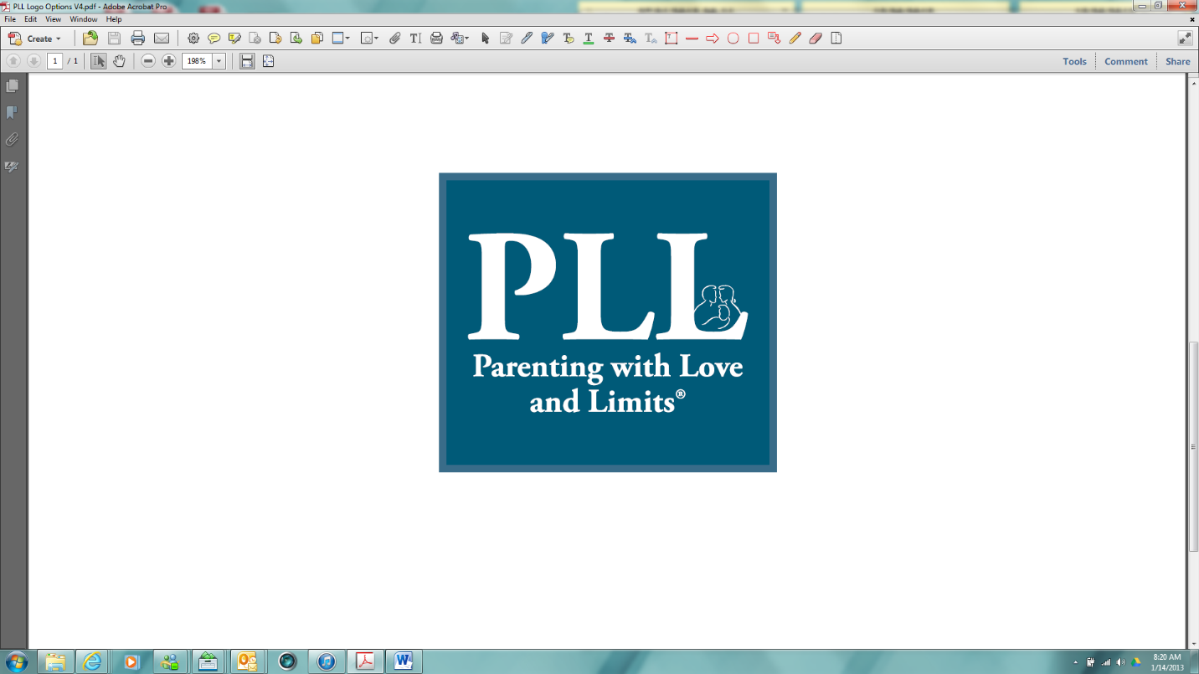

Parent unpredictables

© 2005-2016 Savannah Family Institute, Inc. All rights reserved.

www.gopll.com
www.gopll.com
With the exceptions noted below, no part of these handouts may be reproduced
or transmitted in any form without written permission from Savannah Family Institute, Inc.

LIMITED PHOTOCOPY LICENSE
Savannah Family Institute grants to PLL’s certified mental health professionals non-assignable permission to reproduce pages of these handouts for personal use in clinical practice and not for resale or redistribution. These materials are intended for use only by qualified mental health professionals. This license is limited to the individual participant and does not extend to others. The license does not grant the right to reproduce these materials for other purposes (including but not limited to books, pamphlets, articles, video or audio tapes, handouts or slides for lectures or workshops.) Permission to reproduce these materials for these and any other purposes must be obtained in writing from Savannah Family Institute, Inc.

Parent Unpredictable
The Water Duel. This week get two objects that squirt water. When your teen is in a good mood and you want to have a little fun, call for a duel. You and your teen will go out into the yard and with your backs to one another, walk 10 paces, turn around and squirt water on each other. The winner is the one who drenches the other the most.

Parent Unpredictable
The Whoopee Moment. This week when you sit down at the dinner table, sit on a whoopee cushion but don’t say anything. Be sure to wiggle around during dinner.

Parent Unpredictable
The Surprising Nurturance. This week sometime when you are just talking to your teen, stop in the middle and give him a big kiss on the cheek, say “I love you”, and then exit the room.

Parent Unpredictable
The Silly Wig. Surprise your teen by coming into the room wearing a silly wig as if nothing was different. Keep a straight face as you stay in the room for a few minutes and then exit.

Parent Unpredictable
The Jokester. This week, when everyone is at the dinner table together, announce that you have something important to share. Then with a very serious face, tell a silly joke you read from the Joke Book.

Parent Unpredictable
The Silly Glasses. This week in the middle of a conversation with your teen, whip out a pair of silly glasses, put them on, and continue talking as if nothing is different.

Parent Unpredictable
Dance Fever. This week when your teen comes into the room, turn on the radio or your IPhone to a popular music station and start dancing to the music.

Parent Unpredictable
Dance Fever. This week when your teen comes into the room, turn on the radio or your IPhone to a popular music station and start dancing to the music.

Parent Unpredictable
The Un-Birthday Party. This week surprise your teen and pretend that it is his birthday. To celebrate, have balloons and a poster celebrating your teen’s life and eat Dessert BEFORE the dinner meal.

Parent Unpredictable
The Silly Selfie. This week surprise your teen by sending him several selfie’s in silly poses or with silly faces. End each pic with a text message saying “from your loving parent.”

