

Family

Institute

Post Office Box 30381 • Savannah, GA 31410-0381
(330) 630-9223 • Fax (330) 630-9226
www.gopll.com

Parenting with Love and Limits®: A Parenting Education and Family Counseling Program That Has Reduced Recidivism Rates to 16%

Savannah

The Problem: Juvenile judges, mental health agencies, and juvenile probation departments look for innovative community-based programs that demonstrate the ability to:

- Increase parent involvement
- Reduce “no show” rates:
- Reduce recidivism rates
- Increase counselor effectiveness
- See more youth with less cost due to state-wide budget cuts

The Solution:
- Parenting with Love and Limits® (PLL) is on the OJJDP (Office of Juvenile Justice and Delinquency Prevention) “Model Program” List.
- PLL is the only parenting program that is custom designed to engage unmotivated parents and their children with severe emotional and behavioral problems.
- For youth with primary diagnosis of conduct or oppositional defiant disorder, as well as secondary emotional problems, such as substance abuse, depression. ADHD, etc., or who have any type of symptoms indicating an emotional or behavioral problem.
- Both a treatment and prevention program for any youth at risk of entering the juvenile justice system.
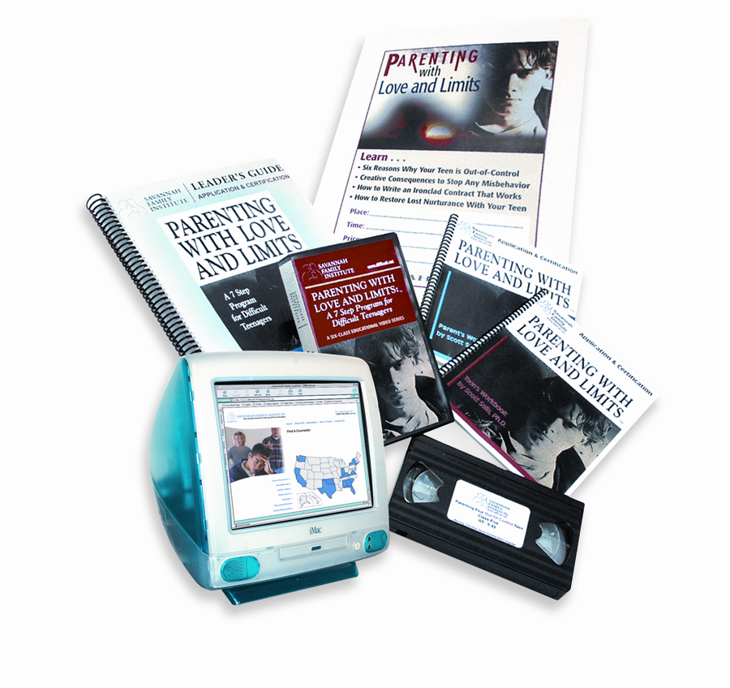 | Parenting with Love and Limits® (PLL) Parenting Group  The PLL parenting group motivates resistant parents and their teenagers and teaches them to become experts to help themselves.  Which is more effective, a counselor doing all the work to convince a burned out parent to get involved with their teen, or employing the collective wisdom of other parents in the trenches to help one another work together and change?

Unique Benefits and Features of Parenting with Love and Limits®
Increased Parental Involvement
- Research studies show that youth will return to past behavioral problems if their parents remain unchanged (Williams and Chang, 2000, p. 159).
- PLL demonstrated a 75% to 80% attendance rate by parents and a 71% to 78% attendance rate by youth.
Reduced Recidivism/Re-Offense Rates
- Recidivism rates after a one-year period dropped to only 16%, versus 55% of youth not in PLL. Youth and parents maintain the changes they make in the parenting group.

- Only 5.9% (six adolescents out of 102) relapsed in their substance abuse or re-offended over a one-year period (94.1% non-recidivism rate). PLL is also effective with substance abuse.

- Detention lengths of stay dropped to only 72 total days vs. 543 days for non-SFI youth.

Why does the Parenting with Love and Limits® Program Work?

#1 A Village Begins to Form
- Parents do not feel alone and isolated - they begin to feel hope
- Parents help each other build ironclad contracts
- Parents find another parent sponsor for support after the group is over
#2 Parents Learn By Doing
- 70% of us learn by what we see and 30% learn by what we hear
- Parents and teens write contracts with other group members help
- Parents and teens role play when they push each other’s buttons
#3 Youth Actively Involved
- Teens are happy that their parents are getting help and it is not only them
- Teens are shocked when they create rewards and parents use them
- Teens like to talk with other teens in their breakout groups
#4 Concrete Tools, Not Theory
Parents are surprised that instead of lectures and theories they receive:
- Tools to stop button pushing, write contracts, think two steps ahead
- Tools to restore lost nurturance and creative consequences to stop disrespect, running away, truancy, drug use, violence, suicide

How Is Parenting With Love and Limits® Implemented?
Savannah Family Institute
Home Office

Responsibilities:

- Train and Supervise Local Service Provider In Each County
- PLL Training
- Provides Supervision
- Oversight of Outcome Research
Medicaid Eligible Provider

Community Mental Health Centers

At-Risk Children from Community
CPS Referrals
Receive Referrals from
Juvenile Justice or Juvenile Court

Step 1: Presentation or Decision to Use PLL System of Care

Step 2: SFI Receives Funding Directly From DJJ /JC, Mental Health and DJJ Partner, or Mental Health Subcontracts with SFI Directly

Step 3: SFI Conducts Five Day Training for PLL Group Therapy and PLL Family Therapy

Step 4: SFI Conducts Weekly Phone Supervision with Service Provider

Cost of Parenting with Love and Limits

- The cost of the program is based on the number of families the mental health agency will serve over a 12-month period using the PLL System of Care.

- Both the Group Therapy and Family Therapy components of PLL are 100% Medicaid reimbursable.

