Complete Graduation Packet

nick’s anti-theft contract (parent Copy)

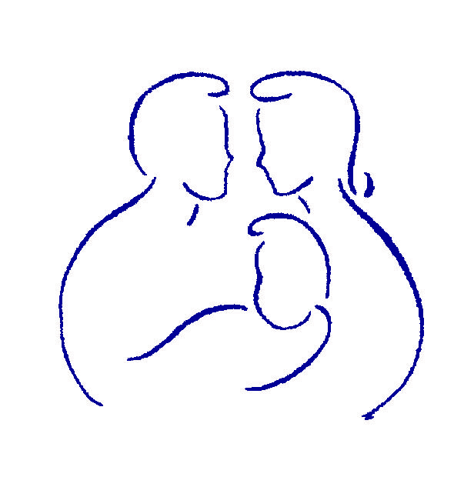

www.gopll.com

Parenting with Love and Limits®

© 2005-2010 Savannah Family Institute, Inc. All rights reserved.
With the exceptions noted below, no part of these documents may be reproduced
or transmitted, in any form, without written permission from Savannah Family Institute, Inc.

LIMITED PHOTOCOPY LICENSE
Savannah Family Institute grants to PLL’s certified mental health professionals non-assignable permission to reproduce pages of these handouts for personal use in clinical practice and not for resale or redistribution. These materials are intended for use only by qualified mental health professionals. This license is limited to the individual participant and does not extend to others. The license does not grant the right to reproduce these materials for other purposes (including but not limited to books, pamphlets, articles, video or audio tapes, handouts or slides for lectures or workshops.) Permission to reproduce these materials for these and any other purposes must be obtained in writing from Savannah Family Institute, Inc.

Nick’s Anti-Theft Contract
Parent Copy

Rule: Nick’s behavior will be considered stealing if he does one or more of the following:
(This clear rule injects Accountability and Consistency into the family)
- Is found in possession of anything that belongs to someone else without their permission or approval (discovered by parents through random checks)
- If Nick tries to interfere with the random check – one of his possessions will automatically be replaced with a pawn ticket and Nick will not get it back until two successful random checks have occurred.
- Nick must also complete the Florida Safety Council Theft Class.


Classic Moves Nick Makes | Parent’s Countermoves
Delivery of rule works well | Mom and Dad present rule together (Dad is the voice); Dad uses a firm tone and good eye contact; Dad emphasizes that he and mom are together and agree on the rule
Nick tries to re-negotiate part of the rule | Parent uses Button Buster (BB#3) Short and to Point “There is no negotiation. This rule is to increase trust.” If Nick argues, use BB#2 Exit and Wait
Nick says “rule is not fair” | Parent uses BB#1 and does not take it personally (thought – “Nick is trying to get me off track”)

CELEBRATIONS (Any celebration earned will be awarded at 9pm that evening)
(These celebrations inject consistency, praise and appreciation, and Nurturance from Dad back into the family)
- 5 Straight Days of no stealing = privilege of going with dad to the Video Arcade with $10 to spend on tokens the upcoming Friday or Saturday night
- 10 Straight Days of no stealing = $15 to spend at Game Stop (will be taken to store within 48 hours)
- 20 Straight Days of no stealing = $20 to spend at mall (dad will take Nick and one friend to mall for 2 hours the upcoming Saturday or Sunday afternoon)
- 30 Straight Days of no stealing = $40 to pay for skate sneakers only
Once Nick has earned his skate sneakers AND completed his Florida Safety Council Theft Class, he will receive a one year membership to the Skate Park

Classic Moves Nick Makes | Parent’s Countermoves
Delivery of celebration reward works well | Mom and Dad deliver Celebration Reward on the day it is earned at 9pm. Also, each night of no stealing, mom and dad go with Nick to the Bonus Calendar to add the sticker and say “Nick, we are so proud of you…you are closer to earning your bonus”
Nick tries to re-negotiate to earn the bonus earlier | Parent uses Button Buster (BB#3) Short and to Point “There is no negotiation at this time, but you only have ___ more days left to earn the bonus.” If Nick argues, use BB#2 Exit and Wait
CONSEQUENCES
(These consequences inject consistency and accountability back into the family and reflect that mom and dad are on the same page)
1st Offense – Within 7 days, Nick will have to publicly (face-to-face) apologize to all involved. Nick will also write an apology letter to all involved. Parties involved will determine how Nick will pay restitution to them. One hour of service hours = every $10 stolen (service hours may be conducting chores or other work to earn the necessary restitution money)
2nd Offense – Immediately one of Nick’s items will automatically be pawned. Nick will still also have to complete the restitution service hours and apologize both in writing (letter) and face-to-face to all involved within 7 days.
3rd Offense – The police are called and charges will be filed in addition to the apology letter and face-to-face apology being completed within 7 days.

Classic Moves Nick Makes | Parent’s Countermoves
Delivery of consequences works well | Mom and Dad deliver consequence together using firm voice and stating only the consequence (using BB#4 Short and to point) Parents also immediately use BB#2 Exit and Wait to avoid “Piling on”
Nick tries to argue about the consequence | Parent uses Button Buster (BB#3) Short and to Point “There is no discussion” and use BB#2 Exit and Wait
Nick does not complete his restitution within one week of receiving the consequence | One of his prized possessions will be removed and pawned.

PARENT’S ROLE TO COUNTERACT CAUSTIC COMMUNICATION

Mom and Dad will inject softness into the family by using the following strategies:
- Parent will use calm voice and stay short and to the point to derail any starts to arguments
- Parent will use Exit and Wait to refuse to engage in any arguments

INCORPORATION OF OTHER FACTORS TO INJECT CLOSENESS BETWEEN DAD AND NICK’S RELATIONSHIP

- Dad will give Nick a PTR daily for the next 30 days to show Nick that Dad is noticing him
- Dad will take Nick to the free local park to skate for 1 hour each Saturday and stay to watch Nick’s skating tricks
Classic Moves Nick Makes | Parent’s Countermoves
What will Dad do if Nick rips up the PTR and/or says he does not care? | Dad will use BB#1 and Not take it personally and think “It may take 30 days to soften Nick up” Dad will tape PTR back together and leave on Nick’s pillow later
What will Dad do if Nick says he does not want to go skating with Dad. | Dad will not take “No” for an answer and playfully cajole Nick into going. If Nick still refuses to get into the car, Dad will calmly say “I’m sorry you feel that way, I love spending time with you…maybe next Saturday”. Dad will also not take it personally (BB#1) and will continue to give the daily PTR’s.

Signatures:

Youth _______________________________________ Date ___________

Mom _______________________________________ Date ___________

Dad _______________________________________ Date ___________

