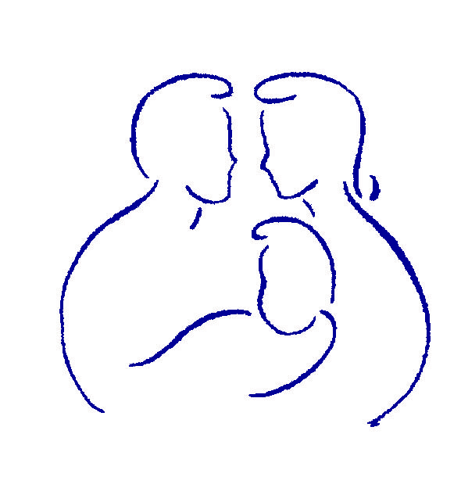

Parenting with Love and Limits®

PARTICIPATION AND GRADUATION AGREEMENT
In order to participate in and graduate from the Parenting with Love and Limits® (PLL) program, I understand and agree to follow these requirements:
- I will attend the mandatory 1st group session.
- I will attend at least 5 out of the 6 group meetings.
If I miss more than 1 group, I understand that I will have to start the PLL program over from the beginning.
- I will attend 4 out of 4 individual (family) coaching sessions over the next six weeks
I am allowed one missed appointment with 24 hours advanced cancellation notice.
More than one missed appointment = No graduation from PLL and not permitted to continue in group.
- I will not arrive late to group or coaching meetings. (Doors will close after 10 minutes)
- Instead of 3 to 6 months, we want to fix the problem in 6 to 7 weeks.

Week | PLL Group | PLL Individual Coaching
Week #1 | Group 1: Venting | No coaching 1st week
Week #2 | Group 2: Button Pushing + → | Coaching #1: Deciding on the Problem to Quickly Fix
Week #3 | Group 3: Contracting + → | Coaching #2: Writing a Loophole Free Contract
Week #4 | Group 4: Putting the Contract + → Together As a Group | Coaching #3: Present Typed Contract to Teenager with Role Plays to Practice
Week #5 | Group 5: Creative Consequences + →  (to stop disrespect, school problems, drug use, violence, not doing chores, running away etc.) | Coaching #4: Relapse Prevention: See if contract worked or tweak contract so it will work better
Week #6 | Group 6: How to Start Liking Each Other Again-Restore Closeness | (If needed)  Coaching #5: To address other problems-Build new contract
Week #7 | No Group | (if needed)  Coaching #6: Present new typed contract

________________________________________________ | ________________________
Parent/Guardian’s Signature | Date
________________________________________________ | ________________________
Youth’s Signature | Date
________________________________________________ | ________________________
Therapist’s Signature | Date

