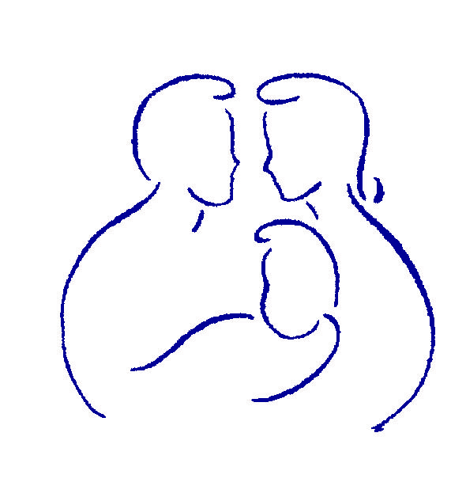

Parenting with Love and Limits®

Participation and graduation Agreement

© 2006-2011 Savannah Family Institute, Inc. All rights reserved.
With the exceptions noted below, no part of these handouts may be reproduced
or transmitted in any form without written permission from Savannah Family Institute, Inc.

LIMITED PHOTOCOPY LICENSE
Savannah Family Institute grants PLL’s certified mental health professionals non-assignable permission to reproduce pages of these handouts for personal use in clinical practice and not for resale or redistribution. These materials are intended for use only by qualified mental health professionals. This license is limited to the individual participant and does not extend to others. The license does not grant the right to reproduce these materials for other purposes (including but not limited to books, pamphlets, articles, video or audio tapes, handouts or slides for lectures or workshops.) Permission to reproduce these materials for these and any other purposes must be obtained in writing from Savannah Family Institute, Inc.
PARTICIPATION AND GRADUATION AGREEMENT

Parenting with Love and Limits®

In order to participate in and graduate from the Parenting with Love and Limits (PLL) program, I understand and agree to follow these requirements:

Week | PLL Group | PLL Individual Coaching
Week #1 | Group 1 – Venting | No coaching 1st week
Week #2 | Group 2 – Button Pushing + → | Coaching #1:  Winning the Battle for Structure and putting all the protective factors on the radar screen
Week #3 | Group 3 – Contracting + → | Coaching #2:  Identifying Undercurrents, Feedback Loops and beginning to develop first Contract and if applicable, Aftercare Plan
Week #4 | Group 4- Putting the Contract + → Together As a Group | Coaching #3:  Continuing to draft written plans
Week #5 | Group 5 – Creative Consequences + →  (to stop disrespect, school problems, drug use, violence, not doing chores, running away etc.) | Coaching #4:  Developing Countermoves around written plans
Week #6 | Group 6- How to Start Liking Each Other Again-Restore Closeness | Coaching #5:  Further development of needed Countermoves and intensive dress rehearsals
Week #7 | No Group | Coaching #6:  Assessment of written plans and changes made as needed
Week #8 + | No Group | Coaching #7: and on…continuing coaching until the following benchmarks are met:  - For youth returning to the community – Finalize Aftercare Plan and insure CBAT Plan is ready to implement  - Additional Coaching to troubleshoot unmet benchmarks (see below) and/or work on additional symptoms or seeds (i.e. unhealed wounds)  - Develop Relapse Prevention Plan  - Make 30/60/90 day callbacks and conduct tune up sessions as needed.

Key Benchmarks

- Attend 5 out of 6 group meetings (1st group mandatory).

- Attend the minimum required individual (family) coaching sessions and continue in coaching until the following benchmarks are met:
Minimum # of family sessions required to Graduate PLL: ______

- In Home- Obeying Curfew and No Leaving Home Without Permission | - Following the PLL Written Plan 80% or greater as Reported by Parents
- In School--Attend school and no ditching, and achieve passing grades | - Show evidence of participation in extracurricular activities, working, or doing community service, as well as meeting all court requirements (i.e. paying restitution, etc.)
- Out of Trouble With the Law (No further violations)

- If applicable, remain Drug Free

__________________________ __________________________ __________________________ _______________
Parent/Guardian’s Signature Youth Signature Therapist Signature Date

