Savannah Family Institute
Helping Professionals, Parents, and Tough Teens Find Solutions
Parenting with Love and Limits®
Family Therapy Model

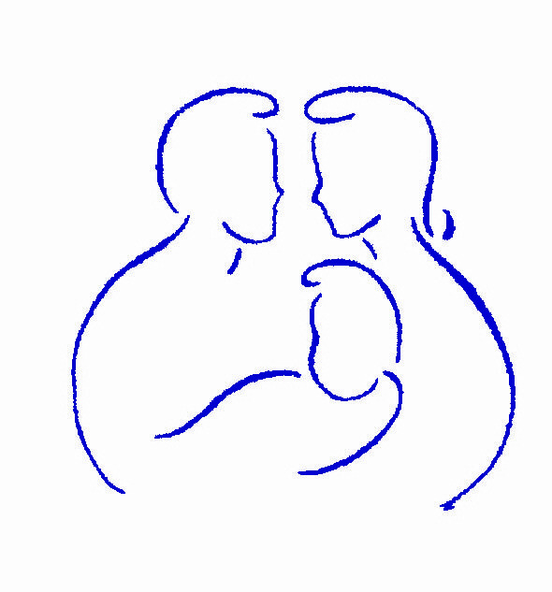

supplemental reading

In preparing for PLL Family Therapy Supervision, please do supplemental reading in the following recommended texts:

- Haley, J. (1987). Problem-solving Therapy. Boston: Jossey-Bass
- Minuchin, S. (1974) Families and Family Therapy. Cambridge, MA: Harvard University Press
- Prochaska, J.O., Norcross, J.C., & DiClemente, C.C. (1994). Changing for Good. New York: Avon Books.
- Selekman, M. D. (1993). Pathways to Change: Brief Therapy Solutions with Difficult Adolescents. New York: Guilford Press.
- Supervising Counselors and Therapists: A Developmental Approach (Jossey-Bass Social and Behavioral Science Series) by CAL D. STOLTENBERG, URSULA DELWORTH

