Savannah Family Institute
Helping Professionals, Parents, and Tough Teens Find Solutions

Parenting with Love and Limits®
Family Therapy certification Planner


Main Office
161 Passaic Lane
Richmond Hill, GA 31324
Toll Free: (800) 735-9525
Direct: (912) 727-2840
FAX (912) 727-2847

Business Development Division :
Diana L. Bala, MA, PCC, NCC
164 Ferguson Drive
Tallmadge, OH 44278-2812
Phone (330) 630-0555
Fax (330) 630-3155
diana@difficult.net

 | Savannah Family Institute  www.difficult.net | 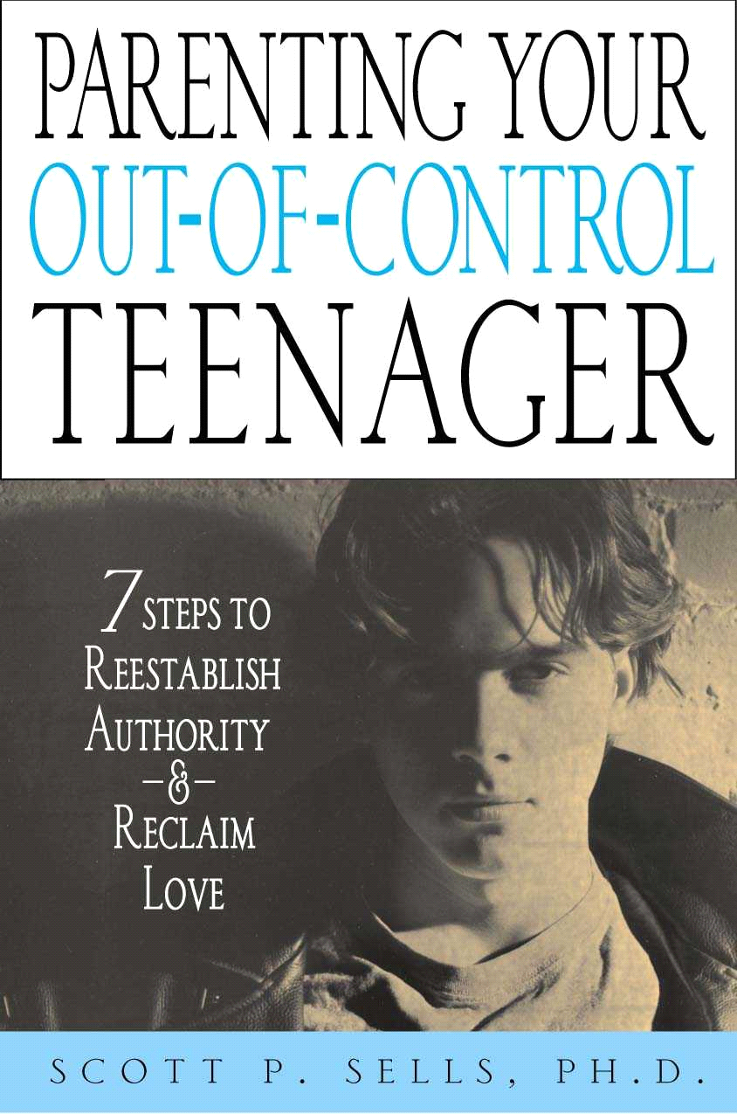  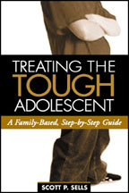

Thank you for your interest in Savannah Family Institute’s Parenting with Love and Limits® Family Therapy Certification Training. We look forward to conducting training for your organization in the near future!

Enclosed you will find information on planning a PLL Family Therapy Certification, including…

- A PLL Family Therapy Certification Checklist
- Complete descriptions, course objectives and agendas for the PLL Family Therapy Certification Training.
- Supplemental Reading List
- A Word about Post-Training Supervision
- About the Author
- Personal bios of our trainers
- Workshop evaluations
- References

Once again, we look forward to working with you. If you have any additional questions, or would like to schedule a certification class, please contact us at the e-mail address or phone number below.

Sincerely,

Scott P. Sells, Ph.D.
Executive Director
Savannah Family Institute
PLL Family Therapy Certification Checklist

- Call and Schedule a Date for Your Training

The first order of business is to call and schedule a date for the training. The calendar fills very quickly, so please call early. One suggestion -- from our experience, therapists working in agencies typically prefer workshops conducted during the work week. On the other hand, professionals in private practice tend to prefer that at least one day of the workshop occur on a weekend so they do not have to miss two days of work.

Savannah Family Institute is proud to have a highly skilled and experienced team of trainers, all hand picked and intensively trained by Dr. Sells (see the attached biographies).

To schedule your workshop, please contact:

Diana L. Bala, Business Development Specialist
Savannah Family Institute
Toll Free 1-800-735-9525
Direct Line (330) 630-0555
Fax (330) 630-3155
Email: diana@difficult.net

- We Will send You a Training Agreement

Once we have settled on a date and scheduled a trainer, we will mail you a simple Training Agreement outlining the details of our agreement. This agreement will include the following information: (1) dates for the workshop; (2) statement of workshop fee and other costs; (3) workshop topic; (4) statement of cancellation policy.

Please note that workshop dates are not guaranteed until the Training Agreement has been received and signed by both parties. You may fax the agreement to SFI at: (912) 727-2847.

- Produce and Mail Your Own Brochure (If open to public)

Upon your request, we will be happy to supply you with sample brochures. Please feel free to copy from these samples to create your own brochure. If you have any questions or would like our input, please call us at 1-800-735-9525.

Parenting with Love and Limits®

Family Therapy Certification



Based on Dr. Sells’ first book, Treating the Tough Adolescent (Guilford, 1998), this two-day Certification training will provide participants with the ability to integrate the 15-step Integrative Model of Practice (IMP) for treating difficult adolescents and their families. Participants will be part of a treatment team that will view families and difficult adolescents through a one-way mirror or closed-circuit television.

At the conclusion of each session, family members will discuss with the group the strengths and weaknesses of the treatment approach. The SFI Trainer will interview difficult and resistant families to demonstrate the process of getting “unstuck” and how to integrate theory into practice. You will receive a Parent Survival Kit, and Book of Handouts (a $150.00 value) as part of your tuition.

It is highly recommended that these trainees have a master’s degree and a good foundation in systems theory.

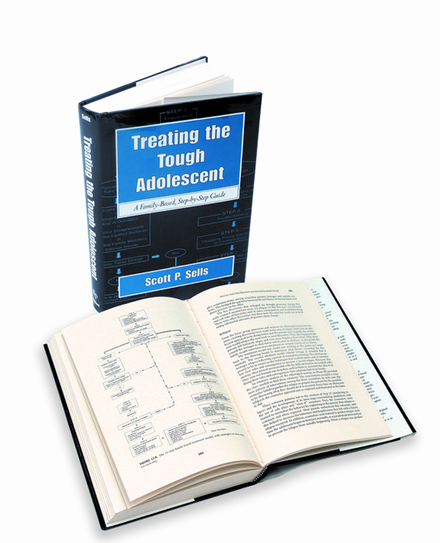 | Treating the Tough Adolescent: A Family-Based, Step by Step Guide  by Scott P. Sells, Ph.D. (Guilford Press, 1998)  This book presents a 15-step treatment model for bringing about improvements in extreme behavioral problems in adolescents, with real-life case examples, troubleshooting tips, and solid empirical support from a four-year research study.

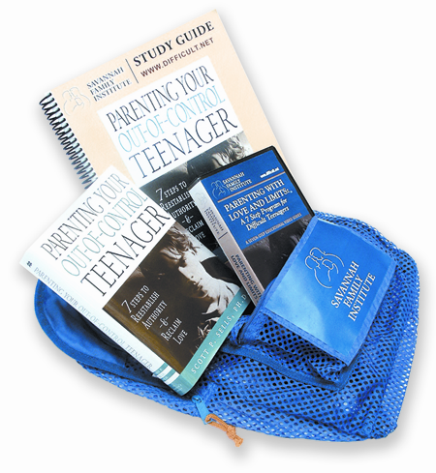 | Parent Survival Kit  - 1 Parenting Your Out-of-Control Teenager Book  - 1 Study Guide  - 1 7-Step Educational Video on DVD  Parents will use the study guide exercises to create their very own contracts custom designed to work with their own teenagers. The book, the video, and the study guide work in tandem to maximize the parents’ knowledge base and ability to quickly turn around their troubled teens.

PLL Family Therapy Program:

Two Day Certification training Agenda

Agenda: Day 1

8:30 AM – 9:30 AM | An Overview of the 15-Step Model (Chapter 3)  Process vs. Content: The Key To Turning the Tide
 | Role-play: How to Gauge the Client’s Readiness/Increase Motivation
9:30 AM – 9:45 AM | BREAK
9:45 AM – 11:00 AM | Engaging the Resistant Parent and Teen: Knowing the Stages of Readiness  ♦ Precontemplation ♦ Contemplation ♦ Preparation ♦ Action ♦ Maintenance and Termination   Video Demonstration: When You Fail To Start Where the Client Is   Video Demonstration: The Boy Who Heard Voices at School
 | Role-play: Moving the Client From One Stage to the Other
11:00 AM – 12:00 PM | Setting Clear Rules and Consequences/Troubleshooting (Chapter 4)
12:00 PM – 1:30 PM | Lunch on Own-See the Sights and Relax
1:00 PM – 2:00 PM | Role Play: Creating Custom Fit Consequences and Troubleshooting  Role Play: Engaging a Tough Adolescent
2:00 PM – 2:15 PM | Break
2:15 PM – 3:15 PM | Button-Pushing: Changing the Process and Timing of Confrontations Between Parent and Teenager (Chapter 5)  8 Anti-Button Pushing Strategies  Role-play: How to prepare parents not to take the bait
3:15 PM – 4:30 PM | Neutralizing the Adolescent’s 7 Aces: A Menu of Consequences That Work (Chapter 6)
5:45 PM – 7:00 PM | Live family counseling session

Agenda: Day #2

8:30 AM – 9:45 AM | In-Depth Discussion of Live Family Sessions  Review of Key Videotaped Segments
9:45 AM – 10:00 AM | BREAK
10:00 AM – 11:00 PM | Role Play: Custom Fit Aces
11:00 PM – 12:00 PM | Mobilizing Outside Helpers Like Friends Neighbors and Police Officers (Chapter 8)
12:00 PM – 1:30 PM | Lunch on Your Own-Relax and See the Sights
1:30 PM – 2:30 PM | Role Play: Working With Outsiders   Video Demonstration: Probation Officers and Empowerment
2:30 PM – 2:45 PM | BREAK
2:30 PM – 3:30 PM | Restoring Nurturance and Tenderness (Chapter 7)  Video Demonstrations: Going Through the Father to Reach the Son; Ray: A Failure in Establishing Nurturance
3:30 PM – 4:30 PM | Role Play: Demonstrating Soft Talk—Wrap-Up

supplemental reading

If possible, please do supplemental reading in the following recommended texts:

- Haley, J. (1987). Problem-solving Therapy. Boston: Jossey-Bass
- Minuchin, S. (1974) Families and Family Therapy. Cambridge, MA: Harvard University Press
- Prochaska, J.O., Norcross, J.C., & DiClemente, C.C. (1994). Changing for Good. New York: Avon Books.
- Selekman, M. D. (1993). Pathways to Change: Brief Therapy Solutions with Difficult Adolescents. New York: Guilford Press.
- Supervising Counselors and Therapists: A Developmental Approach (Jossey-Bass Social and Behavioral Science Series) by CAL D. STOLTENBERG, URSULA DELWORTH

Course Objectives

- Gain an in-depth knowledge of the 15-Step IMP model through hands-on supervision.
- Gain expertise in the use of this model and receive referrals through our interactive website.
- Learn how the model is applied in a real-life situation as you view Dr. Sells working with a live family through a one-way mirror or closed-circuit television.
- Gain an understanding and comprehension of how to break parental resistance once and for all.
- Learn to understand process and find patterns or undercurrents that keep the family stuck.
- Receive interactive supervision from SFI after the 2-day Certification Program is completed.

Post-Training Supervision

Phone Supervision

To assure quality and fidelity of the models, SFI will provide phone supervision by one of our qualified supervisors. Typically, the supervision will be one hour per month for PLL Group Therapy and one hour per month for PLL Family Therapy. This is for a total of 10 months throughout the year. These sessions are vital for these reasons:

- To ensure treatment fidelity of the model and adherence to training procedures. It is normal that trainees will have questions or get stuck at times when trying to implement a new model of practice.

- To ensure more accurate outcome results. One of the biggest criticisms in standard research studies are something called “regression to the mean.” It is normal for trainees who have received a new treatment approach to slide back into their old models. If they stop following the model, the results of the study are skewed, because you cannot be sure that the trainee was actually following the correct procedural steps.

- Many types of crisis situations will come up when the trainers are not on-site. As a result, the phone supervision is an invaluable resource. This will allow your staff to problem solve when they are stuck in the parenting class or have a problem.
About the Author

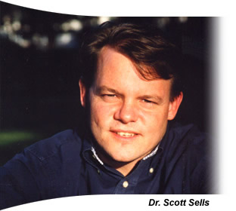 | Due to the wide acceptance of his books, Dr. Scott P. Sells has gained national recognition as an expert in the treatment of difficult teenagers. Currently, his ongoing lecture and workshop schedule reaches thousands of professionals and parents. Dr. Sells has been a practicing therapist for over 15 years, treating over 350 out-of-control teenagers and their families.  Background. Dr. Sells holds doctorate degrees in both Social Work and Family Therapy from Florida State University and a Master’s degree in Social Work. He has previously served as a Full Professor at Savannah State University, teaching masters students in advanced clinical practice. Dr. Sells also serves as a consultant for the Department of Juvenile Justice, and as the
CEO of the Savannah Family Institute. Dr. Sells is receiving widespread media coverage for his work with an inner-city neighborhood, establishing a community center clinic that will treat at-risk children using the principles from his books.

Professional Memberships and Certifications

American Association for Marriage and Family Therapy - Approved Supervisor
Licensed Clinical Social Worker (Lic # 01790-C)
Licensed Marriage and Family Therapist (Lic # 01456)

Publications. Dr. Sells’ first book, entitled Treating the Tough Adolescent: A Family-Based, Step-by-Step Guide (Guilford, 1998), was based upon a four year outcome study of 82 difficult teenagers and their families. This book was featured as the alternate main selection in the Behavioral Science Book Club.

Dr. Sells’ wrote his second book, entitled Parenting Your Out-of-Control Teenager: 7 Steps to Reestablish Authority and Reclaim Love (St. Martin’s, 2001), because current parenting books and counseling programs often did not address the special circumstances specific to the out-of-control teenager. This book is based upon a four year research study and contains the seven critical steps parents need to restore both love and limits with their teenagers.

In addition to these two books, Dr. Sells has had over a dozen major publications in preferred journals, plus a book chapter in the Handbook of Family Therapy Research Methods (Guilford, 1996).

Conference Presentations. Dr. Sells has extensive experience as a keynote speaker for national professional organizations like the American Association of Marriage and Family Therapy, the National Association of Social Workers and the Southeastern Psychological Association. He has also presented at national conferences for the Council on Social Work Education and at state conferences for the Nevada Association for Marriage and Family Therapy, the Georgia Association for Marriage and Family Therapy, the Clinical Social Workers’ Association and the School Social Workers’ Association of Georgia. Dr. Sells was invited to be one of six expert presenters at the American Association of Marriage and Family Therapy’s prestigious Summer Institutes in Park City, Utah, and the Cape Cod Institute in Cape Cod, Massachusetts, honors given only to those in the field who are demonstrating cutting edge work in the field.
Trainer Bios

Scott P. Sells. Ph.D., LCSW has conducted seminars in over 80 cities for the past five years and spoken to over 12,000 professional counselors and parents based on his first book entitled, Treating the Tough Adolescent: A Family-Based, Step-by-Step Guide (New York: Guilford Press, 1998) and his second book entitled Parenting Your Out-of-Control Teenager: 7 Steps to Reestablish Authority and Reclaim Love (New York: St. Martin’s Press, 2001). He is a former Full Professor at Savannah State University and currently the Executive Director of Savannah Family Institute. Over the past fifteen years, Dr. Sells has treated over 350 difficult children.

Steven Burggraf, Ph.D., L.P.C.C. is the founder and Executive Director of Family Life Counseling & Psychiatric Services in Mansfield, Ohio, which was established in 1999. Dr. Burggraf is firmly established in SFI’s Parenting with Love and Limits® System of Care. He received his Ph.D. in Clinical Psychology from Union Institute in 1999, and was licensed as a Professional Clinical Counselor in the state of Ohio in 1996. He specializes in adolescent and family behavioral health, and has been treating the tough adolescents and their families since 1996. Dr. Burggraf is also a Certified Marriage and Family Therapist and has been professionally affiliated with AAMFT since 1996. He has experience in providing psychological evaluations and counseling services for at-risk family members through Children’s Services and Juvenile Court, providing administrative services as Director of Adolescent Mental Health & Substance Abuse Services at a psychiatric hospital, and has worked as a counselor in private practice. Dr. Burggraf is an ordained minister with the Christian and Missionary Alliance denomination, and has pastored in churches in Ohio and Michigan from 1983 to 1999. Dr. Burggraf’s youth was sketched with its own difficulties, and he takes these experiences and relates well with the difficult youth and their family. He uses a systemic approach, and believes strongly in team efforts to bringing wholeness and healing to hurting families.

Ted Stein, CPC has spent the last decade helping unhappy families and couples choose more effective behaviors that result in rediscovering lost love and tenderness. Ted maintains a private practice in La Crosse, Wisconsin called Stein Counseling & Consulting Services, Ltd. And he is the director of SFI Wisconsin. Ted specializes in family, couple, and adolescent counseling using a solution focused approach. He is an adjunct professor at Viterbo University where he teaches Effective Behavior. He has twice been nominated for the University of La Crosse, Wisconsin Rada Distinguished Alumnus award. Ted is a member of the American Counseling Association (ACA), the Association for Specialists in Group Work (ASGW), the International Association of Marriage and Family Counselors (IAMFC), and the Association for Counselor Education and Supervision (ACES). Ted is a member of the distinguished Red Cross Disaster Relief Team Mental Health Services. Additionally, he is a Certified Corrective Thinking Practitioner and Certified Multi-Cultural Competent. Locally, Ted serves on the Juvenile Justice Coalition and the Child Abuse Task Force. He provides clinical supervision and consultation to other mental health professionals in the La Crosse Area. In 2002, Ted had one of his adolescent group services programs objectively evaluated and it was rated in the top 8% in the country for effective treatment of high risk adolescents.

Dan Sabourin has over 17 years of diverse experience with families and youth in various settings and environments, most of it related to youth justice, working with court ordered youth and their families. These settings include both closed and open custody youth between the ages of 12 and 18. Earlier in his career, Dan worked as a youth employment counselor, providing both individual counseling and group facilitation to youth/young adults with employability issues. Dan has been a coordinator/manager for 10 years and recently co-developed a new initiative of offering crisis support for families and their children. He actively trains agency staff in crisis prevention and intervention and co-supervises a small team of family and youth workers. Dan has been trained as a facilitator in the Wraparound process, Community Justice Forums and Child Abuse. In addition, Dan has extensive training and experience in SFI’s Parenting with Love and Limits® System of Care.

Norm St-Georges currently works for a large youth-serving agency in Ottawa, Canada. The agency provides a wide range of services to high risk / high needs youth and their families. He spent the last 23 years providing services to very challenging youth and their families in different capacities and through different types of services. Norm has been a coordinator / manager for 13 of those 23 years. He also actively trains agency and school board staff in crisis prevention, management and intervention. Norm also acts as a consultant for diverse youth and adult-serving agencies to develop intervention strategies for out of control clients and implement action plans as well as train staff delivering those services. Norm also was a part time professor in a community college for a period of 5 years in a program forming youth counselors. Norm currently runs a program for youth who are expelled from the school system. This program provides services to the youth and their families in their own community. Norm has extensive training and experience in SFI’s Parenting with Love and Limits® System of Care..
Workshop Evaluations
The evaluations of the workshops are overwhelmingly favorable based upon the written comments received and the standard evaluation forms returned. Written comments seem to center around a theme that the workshop is highly practical, easy to understand, and fills the need for a step-by-step approach. Sample written comments include:

"I came as a parent, a professional, and a student. Rarely has a workshop been so useful to all the hats I wear.” – Dr. Cynthia Wilburn, Phoenix, Arizona, March 17, 2001

“Motivating, practical, respectful, clear and “do-able” model. I’ve never experienced such a touching workshop that fills me with therapeutic hope”. - Dr. John Marque, Sydney, Australia, March 2002

“The presentation made me excited about new ways of working, something I haven’t felt from a workshop for a long time”. Dr. Lynn James, Jackson Mississippi, June 2002

“Great workshop. Showed us that there is light at the end of the tunnel! That there is a proven program to help my out-of-control teenager”. Betty Rutherford, Parent, January 2002, Chicago, IL.

The results from the standardized evaluation forms are favorable. The following table gives a summary of the numerical ratings from our presentations at the American Association of Marital and Family Therapy (2002), the Georgia Association of Marital and Family Therapy (2002), and the Master’s Therapy Series (2001). These scores are representative of the scores from other workshops, which are also available upon request. Ratings are based on a 6-point scale, with a score of 6 being the highest. Averages for all the participants for each question were calculated.

Conference Session | My Rating | Average Score
American Association of Marital and Family Therapy (>02)
I acquired new skills or knowledge. | 5.67 | 4.54
The presenter had sufficient knowledge and expertise. | 5.57 | 5.05
The method used to present held my attention. | 5.22 | 4.27
The stated learning objectives were met. | 5.37 | 4.95
The presenter presented material in an organized manner. | 5.45 | 5.05

Georgia Association of Marital and Family Therapy (>02)
- I acquired new skills or knowledge. | 5.89 | Not available
- The presenter had sufficient knowledge and expertise. | 5.65 | Not available
- The method used to present held my attention. | 5.77 | Not available
- The stated learning objectives were met. | 5.57 | Not available
- The presenter presented material in an organized manner. | 5.81 | Not available

The Master’s Series Conference (>01)
- I acquired new skills or knowledge. | 5.91 | Not available
- The presenter had sufficient knowledge and expertise. | 5.95 | Not available
- The method used to present held my attention. | 5.87 | Not available
- The stated learning objectives were met. | 5.89 | Not available
- The presenter presented material in an organized manner. | 5.83 | Not available
References

Please feel free to contact any of the individuals listed below who have served as past sponsors of workshops by Savannah Family Institute.

Yvan Roy, M.ED
Clinical Director
Youth Services Bureau
1338 ½ Wellington, Ottawa Canada
Phone # 613-729-1000
E-mail: yvan@ysb.on.ca

Bill Bruinsma, Psy.D.
Executive Director
1000 S. Michigan St.
South Bend, In 46601
Phone # 219-235-5445
Email: bruinsma@jjconline.org

Sander van Arum

Center for Ambulatory Forensic Psychiatry De Waag

Postbus 1362

3500 BJ Utrecht

The Netherlands

Phone # 0031 30 272 0685

Email: Sarum@dewaag-utrecht.nl

Geoffrey Baruch Ph.D.

The Brandon Centre

26 Prince of Wales Road

Kentish Town

London NW5 3LG

England

Phone # 02072674792

Fax # 02072675212

Email: reception@brandon-centre.org.uk

Grant Wood

Kansas City Counseling Associates

7199 W. 98th Terrace

Bldg. #3 Ste. #120

Overland Park, KS. 66212

Phone # 816-765-9606

Email: gewood8900@earthlink.net

