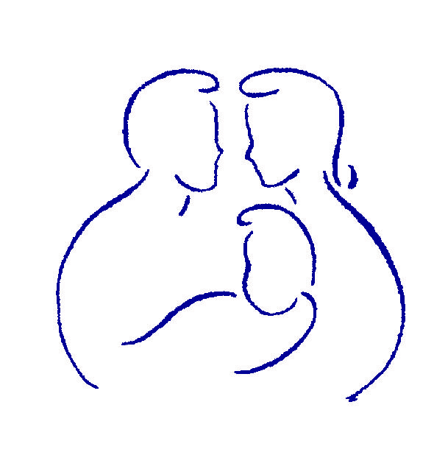
www.gopll.com
Parenting with Love and Limits®

Button Filter Moves
“What will I do if…”

Classic Buttons Pushed  Around Delivery of the Rule | Button Filter Responses  “What I will do…”
Part 1: Delivery of the Rule

- Parent nags and nags

- Parent brings up the past

- Parent calls you names

- Adding to the rule

Classic Buttons Pushed  Around Delivery of the Reward | Button Filter Responses  “What I will do…”
Part 2: Delivery of the Reward

- Parent forgets to give me my reward

- Parent uses a “compliment sandwich”

- Something else
Classic Buttons Pushed  Around Delivery of the Consequence | Button Filter Responses  “What I will do…”
Part 3: Delivery of the Consequence

- Parent uses labels and loses their temper

- Parent “Piles on”

- Something else

Classic Buttons Pushed  Around Softness and Nurturance | Button Filter Responses  “What I will do…”
Part 4: Showing love and nurturance

- Parent forgets to give the PTR

- Parent gets mad about something and backs out of the special outing

- Something else

LIMITED PHOTOCOPY LICENSE
Parenting with Love and Limits grants to individual participants of this handout non-assignable permission to reproduce pages of these handouts for personal use in clinical practice and not for resale or redistribution. These materials are intended for use only by qualified mental health professionals. This license is limited to the individual participant and does not extend to others. The license does not grant the right to reproduce these materials for other purposes (including but not limited to books, pamphlets, articles, video or audio tapes, handouts or slides for lectures or workshops.) Permission to reproduce these materials for these and any other purposes must be obtained in writing from Parenting with Love and Limits (PLL).

