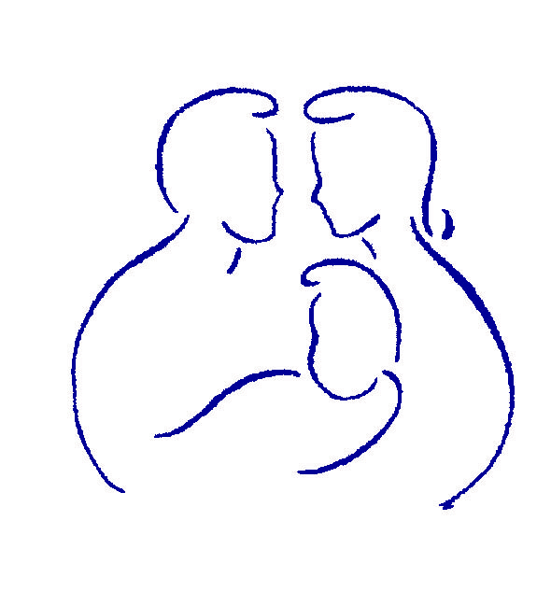

www.gopll.com

PLL Center of Excellence

Parenting with Love and Limits®

Shutdown Checklist

This form is to be filled out and submitted to PLL’s Director of Operations within 60 days of the termination of your Parenting with Love and Limits® license.

Agency Name
Termination Date
Checklist Due Date

Date Completed
- Final COE Report submitted
- “PLL Center of Excellence” signs removed (if applicable)
- PLL references removed from website
- PLL references removed from all marketing documents
- PLL materials inventory destroyed, deleted, or returned to PLL*
PLL Leader’s Guides
PLL Class Videos
Parent Workbooks
Teen Workbooks
Survival Kit Study Guides
Other PLL proprietary materials (including training binders, COE downloads from gopll.com, etc.)
*Copies of the book “Parenting Your Out-of-Control Teenager” do not need to be destroyed or disposed of.
Clinical Requirements | Date Completed
- No more new groups or family therapy scheduled (can continue to finish out existing cases).
- Notified staff that no more clinical supervision provided after Termination Date unless crisis or emergency.
- Notified staff that they are no longer licensed to practice the PLL Model after Termination Date.

I affirm that these tasks have been completed as indicated above.

Signature:
Typed Name:
Title
Agency
Please FAX completed form to Robert Kelly at (866) 512-2067, or mail it to Parenting with Love and Limits,
2651 E. Desert Inn Dr., Chandler, AZ 85249.

