This is to certify that

Name

has completed a continuing education course sponsored by:

www.gopll.com


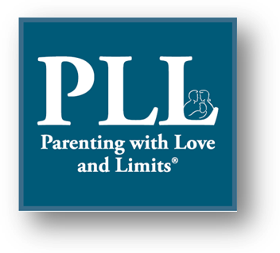

Savannah Family Institute, Inc.
P. O. Box 30381
Savannah, GA 31410-0381
(800) 735-9525

www.gopll.com

Parenting with Love and Limits® Panel Discussion on _________________ |  | Name of Presenter
Course Title |  | Presenter
Date completed |  | 1.5
Date of Completion |  | Contact Hours
Distance Learning |  | Ellen Souder, MA, LPCC-S
Location |  | Program Coordinator

Parenting with Love and Limits® Model Program is approved by the National Association of Social Workers (provider #886516749) for 1.5 continuing education contact hours.

